

DEPARTMENT OF CS & IT
BCA – GENERAL – 4TH SEMESTER
ACADEMIC YEAR : 2024 – 2025 (EVEN SEMESTER)
BATCH : 2023 - 2026

TITLE | PYTHON PROGRAMMING
SUBJECT CODE | 23BCA4C03
HOURS PER WEEK | 3 Hrs/Week
CREDITS | 3

MODULE 4

Prepared by
Dr.A.Kannagi

TOPICS TO BE COVERED
INTRODUCTION TO NUMPY, PANDAS
- Computation on NumPy
- Aggregations
- Computation on Arrays, Comparisons
- Masks and Boolean Arrays
- Fancy Indexing
- Sorting Arrays
- Structured Data: NumPy’s Structured Array.
- Introduction to Pandas Objects
- Data indexing and Selection
- Operating on Data in Pandas
- Handling Missing Data
- Hierarchical Indexing.

- Computation on NumPy
Numpy is a general-purpose array-processing package. It provides a high-performance multidimensional array object, and tools for working with these arrays. It is the fundamental package for scientific computing with Python.
Besides its obvious scientific uses, Numpy can also be used as an efficient multi-dimensional container of generic data.

Arrays in Numpy
Array in Numpy is a table of elements (usually numbers), all of the same type, indexed by a tuple of positive integers. In Numpy, number of dimensions of the array is called rank of the array.
A tuple of integers giving the size of the array along each dimension is known as shape of the array.
An array class in Numpy is called as ndarray. Elements in Numpy arrays are accessed by using square brackets and can be initialized by using nested Python Lists.
Creating a Numpy Array
Arrays in Numpy can be created by multiple ways, with various number of Ranks, defining the size of the Array. Arrays can also be created with the use of various data types such as lists, tuples, etc. The type of the resultant array is deduced from the type of the elements in the sequences.
Note: Type of array can be explicitly defined while creating the array.
# Python program for Creation of Arrays
import numpy as np
# Creating a rank 1 Array
arr = np.array([1, 2, 3])
print("Array with Rank 1: \n",arr)
# Creating a rank 2 Array
arr = np.array([[1, 2, 3],
[4, 5, 6]])
print("Array with Rank 2: \n", arr)
# Creating an array from tuple
arr = np.array((1, 3, 2))
print("\nArray created using passed tuple:\n", arr)
Output
Array with Rank 1:
[1 2 3]
Array with Rank 2:
[[1 2 3]
[4 5 6]]
Array created using passed tuple:
[1 3 2]
Accessing the array Index
In a numpy array, indexing or accessing the array index can be done in multiple ways. To print a range of an array, slicing is done. Slicing of an array is defining a range in a new array which is used to print a range of elements from the original array. Since, sliced array holds a range of elements of the original array, modifying content with the help of sliced array modifies the original array content.
# Python program to demonstrate indexing in numpy array
import numpy as np
# Initial Array
arr = np.array([[-1, 2, 0, 4],
[4, -0.5, 6, 0],
[2.6, 0, 7, 8],
[3, -7, 4, 2.0]])
print("Initial Array: ")
print(arr)
# Printing a range of Array with the use of slicing method
sliced_arr = arr[:2, ::2]
print ("Array with first 2 rows and alternate columns(0 and 2):\n", sliced_arr)
# Printing elements at specific Indices
Index_arr = arr[[1, 1, 0, 3],
[3, 2, 1, 0]]
print ("\nElements at indices (1, 3), (1, 2), (0, 1), (3, 0):\n", Index_arr)
Output
Initial Array:
[[-1. 2. 0. 4. ]
[ 4. -0.5 6. 0. ]
[ 2.6 0. 7. 8. ]
[ 3. -7. 4. 2. ]]
Array with first 2 rows and alternate columns(0 and 2):
[[-1. 0.]
[ 4. 6.]]
Elements a...
Basic Array Operations
In numpy, arrays allow a wide range of operations which can be performed on a particular array or a combination of Arrays. These operations include some basic Mathematical operation as well as Unary and Binary operations.
# Python program to demonstrate basic operations on single array
import numpy as np
# Defining Array 1
a = np.array([[1, 2],
[3, 4]])
# Defining Array 2
b = np.array([[4, 3],
[2, 1]])
# Adding 1 to every element
print ("Adding 1 to every element:", a + 1)
# Subtracting 2 from each element
print ("\nSubtracting 2 from each element:", b - 2)
# sum of array elements
# Performing Unary operations
print ("\nSum of all array "
"elements: ", a.sum())
# Adding two arrays
# Performing Binary operations
print ("\nArray sum:\n", a + b)
Output
Adding 1 to every element: [[2 3]
[4 5]]
Subtracting 2 from each element: [[ 2 1]
[ 0 -1]]
Sum of all array elements: 10
Array sum:
[[5 5]
[5 5]]
More on Numpy Arrays
- Basic Array Operations in Numpy
- Advanced Array Operations in Numpy
- Basic Slicing and Advanced Indexing in NumPy Python

Data Types in Numpy
Every Numpy array is a table of elements (usually numbers), all of the same type, indexed by a tuple of positive integers. Every ndarray has an associated data type (dtype) object. This data type object (dtype) provides information about the layout of the array. The values of an ndarray are stored in a buffer which can be thought of as a contiguous block of memory bytes which can be interpreted by the dtype object. Numpy provides a large set of numeric datatypes that can be used to construct arrays. At the time of Array creation, Numpy tries to guess a datatype, but functions that construct arrays usually also include an optional argument to explicitly specify the datatype.
Constructing a Datatype Object
In Numpy, datatypes of Arrays need not to be defined unless a specific datatype is required. Numpy tries to guess the datatype for Arrays which are not predefined in the constructor function.
# Python Program to create a data type object
import numpy as np
# Integer datatype guessed by Numpy
x = np.array([1, 2])
print("Integer Datatype: ")
print(x.dtype)
# Float datatype guessed by Numpy
x = np.array([1.0, 2.0])
print("\nFloat Datatype: ")
print(x.dtype)
# Forced Datatype
x = np.array([1, 2], dtype = np.int64)
print("\nForcing a Datatype: ")
print(x.dtype)
Output
Integer Datatype:
int64
Float Datatype:
float64
Forcing a Datatype:
int64
Math Operations on DataType array
In Numpy arrays, basic mathematical operations are performed element-wise on the array. These operations are applied both as operator overloads and as functions. Many useful functions are provided in Numpy for performing computations on Arrays such as sum: for addition of Array elements, T: for Transpose of elements, etc.
# Python Program to create # a data type object
import numpy as np
# First Array
arr1 = np.array([[4, 7], [2, 6]],
dtype = np.float64)
# Second Array
arr2 = np.array([[3, 6], [2, 8]],
dtype = np.float64)

# Addition of two Arrays
Sum = np.add(arr1, arr2)
print("Addition of Two Arrays: ")
print(Sum)
# Addition of all Array elements using predefined sum method
Sum1 = np.sum(arr1)
print("\nAddition of Array elements: ")
print(Sum1)
# Square root of Array
Sqrt = np.sqrt(arr1)
print("\nSquare root of Array1 elements: ")
print(Sqrt)
# Transpose of Array using In-built function 'T'
Trans_arr = arr1.T
print("\nTranspose of Array: ")
print(Trans_arr)
Output
Addition of Two Arrays:
[[ 7. 13.]
[ 4. 14.]]
Addition of Array elements:
19.0
Square root of Array1 elements:
[[2. 2.64575131]
[1.41421356 2.44948974]]
Transpose of Array:
[[4. 2.]

Methods in Numpy:
all() | diag() | hypot() | ones_like()
any() | diagflat() | absolute() | full_like()
take() | diag_indices() | ceil() | sin()
put() | asmatrix() | floor() | cos()
apply_along_axis() | bmat() | degrees() | tan()
apply_over_axes() | eye() | radians() | sinh()
argmin() | roll() | npv() | cosh()
argmax() | identity() | fv() | tanh()
nanargmin() | arange() | pv() | arcsin()
nanargmax() | place() | power() | arccos()
amax() | extract() | float_power() | exp()
amin() | compress() | log() | exp2()
insert() | rot90() | log1() | fix()
delete() | tile() | log2() | logical_or()
append() | reshape() | log10() | logical_and()
around() | ravel() | dot() | logical_not()
flip() | isinf() | vdot() | logical_xor()
fliplr() | isrealobj() | trunc() | array_equal()
flipud() | isscalar() | divide() | array_equiv()
triu() | isneginf() | floor_divide() | arctan2()
tril() | isposinf() | true_divide() | equal()
tri() | iscomplex() | random.rand() | not_equal()
empty() | isnan() | random.randn() | less()
empty_like() | iscomplexobj() | ndarray.flat() | less_equal()
zeros() | isreal() | expm1() | greater()
zeros_like() | isfinite() | bincount() | greater_equal()
ones() | isfortran() | rint() | prod()
 | arctan() | cbrt() | square()

- Aggregations
NumPy is a powerful library in Python for numerical and mathematical operations, and it provides various aggregation functions to perform operations on arrays. Aggregation functions in NumPy allow you to perform computations across the entire array or along a specified axis. Here are some commonly used NumPy aggregation functions:
1.numpy.sum: Computes the sum of array elements.
import numpy as np
arr = np.array([[1, 2, 3], [4, 5, 6]])
# Sum of all elements in the array
total_sum = np.sum(arr)
print(“Total Sum:”, total_sum)
# Sum along a specific axis (axis=0 for columns, axis=1 for rows)
column_sum = np.sum(arr, axis=0)
row_sum = np.sum(arr, axis=1)
print(“Column Sum:”, column_sum)
print(“Row Sum:”, row_sum)
2. numpy.mean: Computes the mean (average) of array elements.
arr = np.array([[1, 2, 3], [4, 5, 6]])
# Mean of all elements in the array
average = np.mean(arr)
print(“Mean:”, average)
# Mean along a specific axis
column_mean = np.mean(arr, axis=0)
row_mean = np.mean(arr, axis=1)
print(“Column Mean:”, column_mean)
print(“Row Mean:”, row_mean)
3. numpy.min and numpy.max`: Compute the minimum and maximum values of an array
arr = np.array([[1, 2, 3], [4, 5, 6]])
# Minimum and maximum values in the array
min_value = np.min(arr)
max_value = np.max(arr)
print(“Minimum Value:”, min_value)
print(“Maximum Value:”, max_value)
# Minimum and maximum along a specific axis
min_col = np.min(arr, axis=0)
max_row = np.max(arr, axis=1)
print(“Minimum Value Along Columns:”, min_col)
print(“Maximum Value Along Rows:”, max_row)
4. numpy.median: Computes the median of array elements.
arr = np.array([[1, 2, 3], [4, 5, 6]])
# Median of all elements in the array
median = np.median(arr)
print(“Median:”, median)
# Median along a specific axis
column_median = np.median(arr, axis=0)
row_median = np.median(arr, axis=1)
print(“Column Median:”, column_median)
print(“Row Median:”, row_median)
These are just a few examples of NumPy aggregation functions. NumPy provides many more functions, and you can choose the appropriate one based on your specific needs. These functions are efficient and convenient for performing mathematical operations on large datasets.
- Computation on Arrays, Comparisons

Comparing NumPy Array:
Let’s see the comparison operators that will be used in comparing NumPy Arrays –
- Greater than (>) Or numpy.greater().
- Less Than (<) numpy.less().
- Equal(==) or numpy.equal()
- Not Equal(!=) or numpy.not_equal().
- Greater than and equal to(>=).
- Less than Equal to(<=).
Steps for NumPy Array Comparison:
Step 1: First install NumPy in your system or Environment. By using the following command.
pip install numpy(command prompt)
!pip install numpy(jupyter)
Step 2: Import NumPy module.
import numpy as np
Step 3: Create an array of elements using NumPy Array method.
np.array([elements])
Step 4: Now use comparison operators for comparing NumPy Array.
Example 1:
- Import NumPy module.
- Create array using numpy.array() method.
- Now compare two arrays using greater() method.
# importing NumPy Module
import numpy as np
# Creating Array
a = np.array([1,2,3,4])
b = np.array([3,8,5,6])
# Comparing two arrays
np.greater(a, b)
Output:
array([False, False, False, False])
Time complexity: O(n), where n is the length of the arrays a and b.
Auxiliary space: O(n), where n is the length of the arrays a and b, since we are creating two arrays of size n to store the inputs.
Example 2:
  - Import NumPy module.
  - Create array using numpy.array() method.
  - Now compare two arrays using less() method.
# Importing NumPy Module
import numpy as np
# Creating Array using NumPy
a = np.array([1, 2, 3, 4])
b = np.array([3, 8, 5, 6])
np.less(a, b)
Output:
array([ True, True, True, True])
Example 3:
  - Import NumPy module.
  - Create array using numpy.array() method.
  - Now compare two arrays using equal() method.
# Importing NumPy Module.
import numpy as np
# Create Arrays using np.array() Function.
a = np.array([1, 2, 3, 4])
b = np.array([3, 8, 5, 6])
# Compare a and b array elements
# if the elements in a and b are equal
# it returns True else returns False.
np.equal(a, b)
Output:
array([ False, False, False, False])
Example 4:
  - Import NumPy module.
  - Create array using numpy.array() method.
  - Now compare two arrays using not_equal() method.
# Importing NumPy Module.
import numpy as np
# Create Arrays using np.array() Function.
a = np.array([1, 2, 3, 4])
b = np.array([3, 8, 5, 6])
# Compare a and b array elements if the
# elements in a and b are not equal
# it returns True else returns False.
np.not_equal(a, b)
Output:
array([ True, True, True, True])
Example 5:
  - Import NumPy module.
  - Create array using numpy.array() method.
  - Now compare two arrays using >= operator.
# Importing NumPy Module.
import numpy as np
# Create Arrays using np.array()
# Function.
a = np.array([1, 2, 3, 4])
b = np.array([3, 8, 5, 6])
# it returns if elements in a are
# greater than a equal to b
print(a >= b)
Output:
[False False False False]
Example 6:
  - Import NumPy module.
  - Create array using numpy.array() method.
  - Now compare two arrays using <= operator.
# Importing NumPy Module.
import numpy as np
# Create Arrays using np.array()
# Function.
a = np.array([1, 2, 3, 4])
b = np.array([3, 8, 5, 6])
# it returns if elements in a are less
# than a equal to b
print(a <= b)
Output:
[ True True True True]

Filtering NumPy Arrays:
Filtering means taking the elements which satisfy the condition given by us. For example, Even elements in an array, elements greater than 10 in an array, etc.
Steps for Filtering NumPy Array’s:
  - Import NumPy module.
  - Create arrays using np.array() function.
  - Write any condition for filtering the array.
  - Create a new array with that filtering function.
Note: In Filtering and Comparison both give boolean values as an output.
Example 1:
  - Import NumPy module.
  - Create array using numpy.array() method.
  - Now take a condition for filtering array.
  - Now create a new array that satisfies the condition.
import numpy as np
a = np.array([1, 2, 3, 40, 50, 100, 45, 87, 98])
# Taking a condition to filter the array
filter_ex = a < 16
# Creating new array using Condition.
new_arr = np.array([filter_ex])
# Printing new Array
print(*new_arr)
Output:
[False False False True True True True True True]
Example 2:
  - Import NumPy module.
  - Create array using numpy.array() method.
  - Now take a condition for filtering array.
  - Now create a new array that satisfies the condition.
# Importing NumPy Module
import numpy as np
# Creating Array
a = np.array([1, 2, 3, 40, 50, 100,
45, 87, 98])
# Filtering Condition
filter2 = a % 2 == 0
even = np.array([filter2])
print(*even)
Output:
[False True False True True True False False True]

- Masks and Boolean Arrays

Basics of NumPy Arrays
NumPy stands for Numerical Python. It is a Python library used for working with an array. In Python, we use the list for the array but it’s slow to process. NumPy array is a powerful N-dimensional array object and is used in linear algebra, Fourier transform, and random number capabilities. It provides an array object much faster than traditional Python lists.

Types of Array:
- One Dimensional Array
- Multi-Dimensional Array

One Dimensional Array:
A one-dimensional array is a type of linear array.
One Dimensional Array
Example:
# importing numpy module
import numpy as np
# creating list
list = [1, 2, 3, 4]
# creating numpy array
sample_array = np.array(list)
print("List in python : ", list)
print("Numpy Array in python :", sample_array)
Output:
List in python : [1, 2, 3, 4]
Numpy Array in python : [1 2 3 4]
Check data type for list and array:
print(type(list))
print(type(sample_array))

Output:
<class 'list'>
<class 'numpy.ndarray'>

Multi-Dimensional Array:
Data in multidimensional arrays are stored in tabular form.
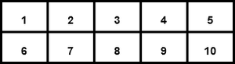
Two Dimensional Array
Example:
# importing numpy module
import numpy as np
# creating list
list_1 = [1, 2, 3, 4]
list_2 = [5, 6, 7, 8]
list_3 = [9, 10, 11, 12]
# creating numpy array
sample_array = np.array([list_1,
list_2,
list_3])
print("Numpy multi dimensional array in python\n",
sample_array)
Output:
Numpy multi dimensional array in python
[[ 1 2 3 4]
[ 5 6 7 8]
[ 9 10 11 12]]
Note: use [ ] operators inside numpy.array() for multi-dimensional

Anatomy of an array :
1. Axis: The Axis of an array describes the order of the indexing into the array.
Axis 0 = one dimensional
Axis 1 = Two dimensional
Axis 2 = Three dimensional

2. Shape: The number of elements along with each axis. It is from a tuple.
Example:
# importing numpy module
import numpy as np
# creating list
list_1 = [1, 2, 3, 4]
list_2 = [5, 6, 7, 8]
list_3 = [9, 10, 11, 12]
# creating numpy array
sample_array = np.array([list_1,
list_2,
list_3])
print("Numpy array :")
print(sample_array)
# print shape of the array
print("Shape of the array :",
sample_array.shape)
Output:
Numpy array :
[[ 1 2 3 4]
[ 5 6 7 8]
[ 9 10 11 12]]
Shape of the array : (3, 4)
Example:
import numpy as np
sample_array = np.array([[0, 4, 2],
[3, 4, 5],
[23, 4, 5],
[2, 34, 5],
[5, 6, 7]])
print("shape of the array :",
sample_array.shape)
Output:
shape of the array : (5, 3)

3. Rank: The rank of an array is simply the number of axes (or dimensions) it has.
The one-dimensional array has rank 1.
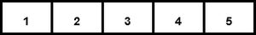
Rank 1
The two-dimensional array has rank 2.
Rank 2
4. Data type objects (dtype): Data type objects (dtype) is an instance of numpy.dtype class. It describes how the bytes in the fixed-size block of memory corresponding to an array item should be interpreted.
Example:
# Import module
import numpy as np
# Creating the array
sample_array_1 = np.array([[0, 4, 2]])
sample_array_2 = np.array([0.2, 0.4, 2.4])
# display data type
print("Data type of the array 1 :",
sample_array_1.dtype)
print("Data type of array 2 :",
sample_array_2.dtype)
Output:
Data type of the array 1 : int32
Data type of array 2 : float64

Some different way of creating Numpy Array :
1. numpy.array(): The Numpy array object in Numpy is called ndarray. We can create ndarray using numpy.array() function.
Syntax: numpy.array(parameter)
Example:
# import module
import numpy as np
#creating a array
arr = np.array([3,4,5,5])
print("Array :",arr)
Output:
Array : [3 4 5 5]
2. numpy.fromiter(): The fromiter() function create a new one-dimensional array from an iterable object.
Syntax: numpy.fromiter(iterable, dtype, count=-1)
Example 1:
#Import numpy module
import numpy as np
# iterable
iterable = (a*a for a in range(8))
arr = np.fromiter(iterable, float)
print("fromiter() array :",arr)
Output:
fromiter() array : [ 0. 1. 4. 9. 16. 25. 36. 49.]
Example 2:
import numpy as np
var = "Geekforgeeks"
arr = np.fromiter(var, dtype = 'U2')
print("fromiter() array :", arr)
Output:
fromiter() array : [‘G’ ‘e’ ‘e’ ‘k’ ‘f’ ‘o’ ‘r’ ‘g’ ‘e’ ‘e’ ‘k’ ‘s’]
3. numpy.arange(): This is an inbuilt NumPy function that returns evenly spaced values within a given interval.
Syntax: numpy.arange( start , stop, step , dtype=None )
Example:
import numpy as np
np.arange(1, 20 , 2, dtype = np.float32)
Output:
array([ 1., 3., 5., 7., 9., 11., 13., 15., 17., 19.], dtype=float32)
4. numpy.linspace(): This function returns evenly spaced numbers over a specified between two limits.
Syntax: numpy.linspace(start, stop, num=50, endpoint=True, retstep=False, dtype=None, axis=0)
Example 1:
import numpy as np
np.linspace(3.5, 10, 3)
Output:
array([ 3.5 , 6.75, 10. ])
Example 2:
import numpy as np
np.linspace(3.5, 10, 3,
dtype = np.int32)
Output:
array([ 3, 6, 10])
5. numpy.empty(): This function create a new array of given shape and type, without initializing value.
Syntax: numpy.empty(shape, dtype=float, order=’C’)
Example:
import numpy as np
np.empty([4, 3],
dtype = np.int32,
order = 'f')
- 'f' stands for Fortran-style column-major order (as used in Fortran).
- (In contrast, 'C' would mean C-style row-major order, which is the default in NumPy.)
- Fortran-order is useful if the array will be used with Fortran code or libraries that expect this layout, or in operations where column-major layout improves performance.

Output:
array([[ 1, 5, 9],
[ 2, 6, 10],
[ 3, 7, 11],
[ 4, 8, 12]])
6. numpy.ones(): This function is used to get a new array of given shape and type, filled with ones(1).
Syntax: numpy.ones(shape, dtype=None, order=’C’)
Example:
import numpy as np
np.ones([4, 3],
dtype = np.int32,
order = 'f')
Output:
array([[1, 1, 1],
[1, 1, 1],
[1, 1, 1],
[1, 1, 1]])
7. numpy.zeros(): This function is used to get a new array of given shape and type, filled with zeros(0).
Syntax: numpy.ones(shape, dtype=None)
Example:
import numpy as np
np.zeros([4, 3],
dtype = np.int32,
order = 'f')
Output:
array([[0, 0, 0],
[0, 0, 0],
[0, 0, 0],
[0, 0, 0]])

Python | Numpy MaskedArray.__mod__

What is a mask?
A boolean array, used to select only certain elements for an operation
# A mask example
import numpy as np
x = np.arange(5)
print(x)
mask = (x > 2)
print(mask)
x[mask] = -1
print(x)
Output:
[0 1 2 3 4]
[False False False True True]
[ 0 1 2 -1 -1]
numpy.ma.MaskedArray class is a subclass of ndarray designed to manipulate numerical arrays with missing data. With the help of Numpy MaskedArray.__mod__ every element in masked array is operated on binary operator i.e mod(%). Remember we can use any type of values in an array and value for mod is applied as the parameter in MaskedArray.__mod__().
Syntax: numpy.MaskedArray.__mod__
Return: Return self%value.
Example #1 :
We can see that value that we have passed through MaskedArray.__mod__() method is used to perform the mod operation with every element of an array.

# import the important module in python
import numpy as np
# make an array with numpy
gfg = np.ma.array([1, 2.5, 3, 4.8, 5])
# applying MaskedArray.__mod__() method
print(gfg.__mod__(2))
Output:
[1.0 0.5 1.0 0.7999999999999998 1.0]
Example #2:
# import the important module in python
import numpy as np
# make an array with numpy
gfg = np.ma.array([[1, 2, 3, 4.45, 5],
[6, 5.5, 4, 3, 2.62]])
# applying MaskedArray.__mod__() method
print(gfg.__mod__(3))
Output:
[[1.0 2.0 0.0 1.4500000000000002 2.0]
[0.0 2.5 1.0 0.0 2.62]]

Numpy MaskedArray.sum() function
numpy.MaskedArray.median() function is used to compute the sum of the masked array elements over the given axis.
Syntax : numpy.ma.sum(arr, axis=None, dtype=None, out=None, keepdims=False)
Parameters:
arr : [ ndarray ] Input masked array.
axis :[ int, optional] Axis along which the sum is computed. The default (None) is to compute the sum over the flattened array.
dtype : [dtype, optional] Type of the returned array, as well as of the accumulator in which the elements are multiplied.
out : [ndarray, optional] A location into which the result is stored.
-> If provided, it must have a shape that the inputs broadcast to.
-> If not provided or None, a freshly-allocated array is returned.
keepdims :[ bool, optional] If this is set to True, the axes which are reduced are left in the result as dimensions with size one. With this option, the result will broadcast correctly against the input array.
Return : [sum_along_axis, ndarray] A new array holding the result is returned unless out is specified, in which case a reference to out is returned.
Code #1 :
# Python program explaining
# numpy.MaskedArray.sum() method
# importing numpy as geek
# and numpy.ma module as ma
import numpy as geek
import numpy.ma as ma
# creating input array
in_arr = geek.array([[1, 2], [ 3, -1], [ 5, -3]])
print ("Input array : ", in_arr)
# Now we are creating a masked array.
# by making entry as invalid.
mask_arr = ma.masked_array(in_arr, mask =[[1, 0], [ 1, 0], [ 0, 0]])
print ("Masked array : ", mask_arr)
# applying MaskedArray.sum
# methods to masked array
out_arr = ma.sum(mask_arr)
print ("sum of masked array along default axis : ", out_arr)
#2 + (-1) + 5 + (-3) = 3
Output:
Input array : [[ 1 2]
[ 3 -1]
[ 5 -3]]
Masked array : [[-- 2]
[-- -1]
[5 -3]]
sum of masked array along default axis : 3
Code #2 :
# Python program explaining # numpy.MaskedArray.sum() method
# importing numpy as geek and numpy.ma module as ma
import numpy as geek
import numpy.ma as ma
# creating input array
in_arr = geek.array([[1, 0, 3], [ 4, 1, 6]])
print ("Input array : ", in_arr)
# Now we are creating a masked array.
# by making one entry as invalid.
mask_arr = ma.masked_array(in_arr, mask =[[ 0, 0, 0], [ 0, 0, 1]])
print ("Masked array : ", mask_arr)
# applying MaskedArray.sum methods to masked array
out_arr1 = ma.sum(mask_arr, axis = 0)
print ("sum of masked array along 0 axis : ", out_arr1)
out_arr2 = ma.sum(mask_arr, axis = 1)
print ("sum of masked array along 1 axis : ", out_arr2)
Output:
Input array : [[1 0 3]
[4 1 6]]
Masked array [[1 0 3]
[4 1 --]]
sum of masked array along 0 axis : [5 1 3]
sum of masked array along 1 axis : [4 5]

- FANCY INDEXING
In NumPy, fancy indexing allows us to use an array of indices to access multiple array elements at once.
Fancy indexing can perform more advanced and efficient array operations, including conditional filtering, sorting, and so on.
Select Multiple Elements Using NumPy Fancy Indexing
import numpy as np
# create a numpy array
array1 = np.array([1, 2, 3, 4, 5, 6, 7, 8])
# select elements at index 1, 2, 5, 7
select elements = array1[[1, 2, 5, 7]]
print(select elements)
# Output: [2 3 6 8]
In this example, the resulting array select elements contains the elements of array1 that correspond to the indices [1, 2, 5, 7] which are 2, 3, 6, and 8 respectively.

Example: NumPy Fancy Indexing
import numpy as np
array1 = np.array([1, 2, 3, 4, 5, 6, 7, 8])
# select a single element
simple_indexing = array1[3]
print("Simple Indexing:",simple_indexing) # 4
# select multiple elements
fancy_indexing = array1[[1, 2, 5, 7]]
print("Fancy Indexing:",fancy_indexing) # [2 3 6 8]
Output
Simple Indexing: 4
Fancy Indexing: [2 3 6 8]
Fancy Indexing for Sorting NumPy Array
Fancy indexing can also sort a NumPy array. Let's see an example.
import numpy as np
array1 = np.array([3, 2, 6, 1, 8, 5, 7, 4])
# sort array1 using fancy indexing
sorted_array = array1[np.argsort(array1)]
print(sorted_array)
# Output: [1, 2, 3, 4, 5, 6, 7, 8]
Here, we are using the fancy indexing with the argsort() function to sort the array1 in the ascending order.
We could also use fancy indexing to sort the array in descending order.
import numpy as np
array1 = np.array([3, 2, 6, 1, 8, 5, 7, 4])
# sort array1 using fancy indexing in descending order
sorted_array = array1[np.argsort(-array1)]
print(sorted_array)
# Output: [8 7 6 5 4 3 2 1]
Here, first we multiplied array1 by -1 to sort in descending order and then used the fancy indexing to return the sorted array.
Fancy Indexing to Assign New Values to Specific Elements
We can also assign new values to specific elements of a NumPy array using fancy indexing. For example,
import numpy as np
array1 = np.array([3, 2, 6, 1, 8, 5, 7, 4])
# create a list of indices to assign new values indices = [1, 3, 6]
# create a new array of values to assign
new_values = [10, 20, 30]
# use fancy indexing to assign new values to specific elements
array1[indices] = new_values
print(array1)
# Output: [ 3 10 6 20 8 5 30 4]
In this example, first we have created a list of indices called indices which specifies the elements of array1 that we want to assign new values to.
Then we created the array for new values called new_values that we want to assign to the specified indices.
Finally, we used fancy indexing with the list of indices to assign the new values to the specified elements of array1.
Fancy Indexing on N-d Arrays
We can also use fancy indexing on multi-dimensional arrays.
Let's see an example to select specific rows using fancy indexing.
import numpy as np
# create a 2D array
array1 = np.array([[1, 3, 5],
[11, 7, 9],
[13, 18, 29]])
# create an array of row indices
row_indices = np.array([0, 2])
# use fancy indexing to select specific rows
selected_rows = array1[row_indices, :]
print(selected_rows)
Output
[[ 1 3 5]
[13 18 29]]
Here, we have created a 2D array named array1 and an array of row indices named row_indices.

Exploring Fancy Indexing
Fancy indexing is conceptually simple: it means passing an array of indices to access multiple array elements at once. For example, consider the following array:
In [1]:
import numpy as np
rand = np.random.RandomState(42)
x = rand.randint(100, size=10)
print(x)
output : [51 92 14 71 60 20 82 86 74 74]
Suppose we want to access three different elements. We could do it like this:
In [2]:
[x[3], x[7], x[2]]
Out[2]:
[71, 86, 14]
Alternatively, we can pass a single list or array of indices to obtain the same result:
In [3]:
ind = [3, 7, 4]
x[ind]
Out[3]:
array([71, 86, 60])
When using fancy indexing, the shape of the result reflects the shape of the index arrays rather than the shape of the array being indexed:
In [4]:
ind = np.array([[3, 7],
[4, 5]])
x[ind]
Out[4]:
array([[71, 86],
[60, 20]])
Fancy indexing also works in multiple dimensions. Consider the following array:
In [5]:
X = np.arange(12).reshape((3, 4))
X
Out[5]:
array([[ 0, 1, 2, 3],
[ 4, 5, 6, 7],
[ 8, 9, 10, 11]])
Like with standard indexing, the first index refers to the row, and the second to the column:
In [6]:
row = np.array([0, 1, 2])
col = np.array([2, 1, 3])
X[row, col]
Out[6]:
array([ 2, 5, 11])
Notice that the first value in the result is X[0, 2], the second is X[1, 1], and the third is X[2, 3]. The pairing of indices in fancy indexing follows all the broadcasting rules that were mentioned in Computation on Arrays: Broadcasting. So, for example, if we combine a column vector and a row vector within the indices, we get a two-dimensional result:
In [7]:
X[row[:, np.newaxis], col]
Out[7]:
array([[ 2, 1, 3],
[ 6, 5, 7],
[10, 9, 11]])

Let's go line by line:
X[row[:, np.newaxis], col]
This is using advanced (fancy) indexing with NumPy. Let’s decompose it.

Step 1: Understand row and col
row = np.array([0, 1, 2])
col = np.array([1, 0, 2])
Then:
row[:, np.newaxis]
will reshape row from shape (3,) to (3, 1):
array([[0],
[1],
[2]])
This allows broadcasting to happen with the next array col, which is still shape (3,).
So when you do:
X[row[:, np.newaxis], col]
You are creating a 3x3 grid of indices, like this:
[
[X[0,1], X[0,0], X[0,2]],
[X[1,1], X[1,0], X[1,2]],
[X[2,1], X[2,0], X[2,2]]
]
Because row[:, np.newaxis] gives:
[[0],
[1],
[2]]
And col is:
[1, 0, 2]
The shapes broadcast to (3, 3), combining each row index with each column index.

Step 2: Output
Your output:
array([[ 2, 1, 3],
[ 6, 5, 7],
[10, 9, 11]])
Tells us that X is likely:
X = np.array([
[1, 2, 3],
[5, 6, 7],
[9,10,11]
])
Because:
- X[0,1] = 2
- X[0,0] = 1
- X[0,2] = 3
- X[1,1] = 6
- X[1,0] = 5
- X[1,2] = 7
- etc.

Here, each row value is matched with each column vector, exactly as we saw in broadcasting of arithmetic operations. For example:

In [8]:
row[:, np.newaxis] * col
Out[8]:
array([[0, 0, 0],
[2, 1, 3],
[4, 2, 6]])
It is always important to remember with fancy indexing that the return value reflects the broadcasted shape of the indices, rather than the shape of the array being indexed.

Combined Indexing
For even more powerful operations, fancy indexing can be combined with the other indexing schemes we've seen:
In [9]:
print(X)
[[ 0 1 2 3]
[ 4 5 6 7]
[ 8 9 10 11]]
We can combine fancy and simple indices:
In [10]:
X[2, [2, 0, 1]]
Out[10]:
array([10, 8, 9])
We can also combine fancy indexing with slicing:
In [11]:
X[1:, [2, 0, 1]]
Out[11]:
array([[ 6, 4, 5],
[10, 8, 9]])
And we can combine fancy indexing with masking:
In [12]:
mask = np.array([1, 0, 1, 0], dtype=bool)
X[row[:, np.newaxis], mask]
Out[12]:
array([[ 0, 2],
[ 4, 6],
[ 8, 10]])
All of these indexing options combined lead to a very flexible set of operations for accessing and modifying array values.

Example: Selecting Random Points
One common use of fancy indexing is the selection of subsets of rows from a matrix. For example, we might have an NN by DD matrix representing NN points in DD dimensions, such as the following points drawn from a two-dimensional normal distribution:
In [13]:
mean = [0, 0]
cov = [[1, 2],
[2, 5]]
X = rand.multivariate_normal(mean, cov, 100)
X.shape
Out[13]:
(100, 2)
Using the plotting tools we will discuss in Introduction to Matplotlib, we can visualize these points as a scatter-plot:
In [14]:
%matplotlib inline
import matplotlib.pyplot as plt
import seaborn; seaborn.set() # for plot styling
plt.scatter(X[:, 0], X[:, 1]);
Let's use fancy indexing to select 20 random points. We'll do this by first choosing 20 random indices with no repeats, and use these indices to select a portion of the original array:
In [15]:
indices = np.random.choice(X.shape[0], 20, replace=False)
indices
Out[15]:
array([93, 45, 73, 81, 50, 10, 98, 94, 4, 64, 65, 89, 47, 84, 82, 80, 25, 90, 63, 20])
In [16]:
selection = X[indices] # fancy indexing here
selection.shape
Out[16]:
(20, 2)
Now to see which points were selected, let's over-plot large circles at the locations of the selected points:
In [17]:
plt.scatter(X[:, 0], X[:, 1], alpha=0.3)
plt.scatter(selection[:, 0], selection[:, 1],
facecolor='none', s=200);

This sort of strategy is often used to quickly partition datasets, as is often needed in train/test splitting for validation of statistical models (see Hyperparameters and Model Validation), and in sampling approaches to answering statistical questions.

Modifying Values with Fancy Indexing
Just as fancy indexing can be used to access parts of an array, it can also be used to modify parts of an array. For example, imagine we have an array of indices and we'd like to set the corresponding items in an array to some value:
In [18]:
x = np.arange(10)
i = np.array([2, 1, 8, 4])
x[i] = 99
print(x)
[ 0 99 99 3 99 5 6 7 99 9]
We can use any assignment-type operator for this. For example:
In [19]:
x[i] -= 10
print(x)
[ 0 89 89 3 89 5 6 7 89 9]
Notice, though, that repeated indices with these operations can cause some potentially unexpected results. Consider the following:
In [20]:
x = np.zeros(10)
x[[0, 0]] = [4, 6]
print(x)
[ 6. 0. 0. 0. 0. 0. 0. 0. 0. 0.]
Where did the 4 go? The result of this operation is to first assign x[0] = 4, followed by x[0] = 6. The result, of course, is that x[0] contains the value 6.
Fair enough, but consider this operation:
In [21]:
i = [2, 3, 3, 4, 4, 4]
x[i] += 1
x
Out[21]:
array([ 6., 0., 1., 1., 1., 0., 0., 0., 0., 0.])

Step-by-step:

1. Initial Setup (assumed)
Assuming x is a NumPy array, probably initialized like this before:
x = np.zeros(10)
x[0] = 6
So x before the operation would be:
array([6., 0., 0., 0., 0., 0., 0., 0., 0., 0.])

2. Indexing with i
You're indexing x using:
i = [2, 3, 3, 4, 4, 4]
This selects:
x[2], x[3], x[3], x[4], x[4], x[4]
So if you were doing this in a loop:
for idx in i:
x[idx] += 1
You would expect:
- x[2] += 1 → 1
- x[3] += 1 → 1
- x[3] += 1 again → 2
- x[4] += 1 → 1
- x[4] += 1 again → 2
- x[4] += 1 again → 3
So you'd think the output should be:
x = [6., 0., 1., 2., 3., 0., 0., 0., 0., 0.]

3. But Wait—That’s Not What Happened!
Instead, you got:
array([6., 0., 1., 1., 1., 0., 0., 0., 0., 0.])

🤯 Why?
This is because of how NumPy handles fancy indexing + in-place operations.
When you do:
x[i] += 1
NumPy does not increment elements in place individually when using repeated indices.
Instead, what happens:
- x[i] creates a temporary array with the selected elements.
- += 1 adds 1 to each element of that temporary array.
- The modified values are then written back to the original array, but only once per index!
So for x[3], which appears twice in i, the result is as if it was only incremented once.
Same for x[4], even though it appears three times, it’s incremented just once.

Correct way if you want to increment multiple times:
Use np.add.at:
np.add.at(x, i, 1)
That does handle repeated indices properly.
With that, you'd get:
array([6., 0., 1., 2., 3., 0., 0., 0., 0., 0.])

In [22]:
x = np.zeros(10)
np.add.at(x, i, 1)
print(x)
[ 0. 0. 1. 2. 3. 0. 0. 0. 0. 0.]
The at() method does an in-place application of the given operator at the specified indices (here, i) with the specified value (here, 1). Another method that is similar in spirit is the reduceat() method of ufuncs, which you can read about in the NumPy documentation.

Example: Binning Data
You can use these ideas to efficiently bin data to create a histogram by hand. For example, imagine we have 1,000 values and would like to quickly find where they fall within an array of bins. We could compute it using ufunc.at like this:
In [23]:
np.random.seed(42)
x = np.random.randn(100)
# compute a histogram by hand
bins = np.linspace(-5, 5, 20)
counts = np.zeros_like(bins)
# find the appropriate bin for each x
i = np.searchsorted(bins, x)
# add 1 to each of these bins
np.add.at(counts, i, 1)
The counts now reflect the number of points within each bin–in other words, a histogram:
In [24]:
# plot the results
plt.plot(bins, counts, linestyle='steps');

Of course, it would be silly to have to do this each time you want to plot a histogram. This is why Matplotlib provides the plt.hist() routine, which does the same in a single line:
plt.hist(x, bins, histtype='step');
This function will create a nearly identical plot to the one seen here. To compute the binning, matplotlib uses the np.histogram function, which does a very similar computation to what we did before. Let's compare the two here:
In [25]:
print("NumPy routine:")
%timeit counts, edges = np.histogram(x, bins)

print("Custom routine:")
%timeit np.add.at(counts, np.searchsorted(bins, x), 1)
NumPy routine:
10000 loops, best of 3: 97.6 µs per loop
Custom routine:
10000 loops, best of 3: 19.5 µs per loop
Our own one-line algorithm is several times faster than the optimized algorithm in NumPy! How can this be? If you dig into the np.histogram source code (you can do this in IPython by typing np.histogram??), you'll see that it's quite a bit more involved than the simple search-and-count that we've done; this is because NumPy's algorithm is more flexible, and particularly is designed for better performance when the number of data points becomes large:
In [26]:
x = np.random.randn(1000000)
print("NumPy routine:")
%timeit counts, edges = np.histogram(x, bins)

print("Custom routine:")
%timeit np.add.at(counts, np.searchsorted(bins, x), 1)
NumPy routine:
10 loops, best of 3: 68.7 ms per loop
Custom routine:
- oops, best of 3: 135 ms per loop
- SORTING ARRAYS

NumPy Array Sorting | How to sort NumPy Array
Sorting an array is a very important step in data analysis as it helps in ordering data, and makes it easier to search and clean.
we will learn how to sort an array in NumPy. You can sort an array in NumPy:
- Using np.sort() function
  - in-line sort
  - sorting along different axes
- Using np.argsort() function
- Using np.lexsort() function

Using sort() function
sort() method sorts the element of a given data structure (here array). Call the sort function with the array object to sort the elements.
There are two cases of sorting array with the sort() method:
- Sort NumPy array in place
- Sort NumPy array along axes
We’ll cover both these methods with an example below:

Sort array In-Place
Sorting an array in place means directly sorting original array elements.
It does not create a new array copy and is very memory efficient.

Example
Using the sort() method to sort elements in the NumPy array in place.
# importing libraries
import numpy as np
a = np.array([12, 15, 10, 1])
print("Array before sorting",a)
a.sort()
print("Array after sorting",a)
Output:
Array before sorting [12 15 10 1]
Array after sorting [ 1 10 12 15]

Sort Array Along Different Axes
This method creates a sorted copy of the given NumPy array.
It is mostly used in a multi-dimensional array when you want to sort along a given dimension.

Example
Using the sort() method to elements in the NumPy array along the axis
# importing libraries
import numpy as np
# sort along the first axis
a = np.array([[12, 15], [10, 1]])
arr1 = np.sort(a, axis = 0)
print ("Along first axis : \n", arr1)
# sort along the last axis
a = np.array([[10, 15], [12, 1]])
arr2 = np.sort(a, axis = -1)
print ("\nAlong first axis : \n", arr2)
a = np.array([[12, 15], [10, 1]])
arr1 = np.sort(a, axis = None)
print ("\nAlong none axis : \n", arr1)
Output:
Along first axis : [[10 1] [12 15]]
Along first axis : [[10 15] [ 1 12]]
Along none axis : [ 1 10 12 15]

Using argsort()
argsort() method is an indirect way of sorting the NumPy array along a given axis.
It returns an array of indices that would sort the original array in ascending order.

Example
Using argsort() to sort elements in the NumPy array
import numpy as np
# Numpy array created
a = np.array([9, 3, 1, 7, 4, 3, 6])
# unsorted array print
print('Original array:\n', a)
# Sort array indices
b = np.argsort(a)
print('Sorted indices of original array->', b)
# To get sorted array using sorted indices
# c is temp array created of same len as of b
c = np.zeros(len(b), dtype = int)
for i in range(0, len(b)):
c[i]= a[b[i]]
print('Sorted array->', c)

Output:
Original array:
[9 3 1 7 4 3 6]
Sorted indices of original array-> [2 1 5 4 6 3 0]
Sorted array-> [1 3 3 4 6 7 9]

Using Sequence of Keys
Sorting an array using a sequence of keys allows us to sort an array based on multiple criteria.
You can use this method with np.lexsort() function. The lexsort() function returns an array of indices that would sort the original array.

Example
Get stable sort using a sequence of keys.
import numpy as np
# Numpy array created
# First column
a = np.array([9, 3, 1, 3, 4, 3, 6])
# Second column
b = np.array([4, 6, 9, 2, 1, 8, 7])
print('column a, column b')
for (i, j) in zip(a, b):
print(i, ' ', j)
# Sort by a then by b
ind = np.lexsort((b, a))
print('Sorted indices->', ind)
Output:
column a, column b
9 4
3 6
1 9
3 2
4 1
3 8
6 7
Sorted indices-> [2 3 1 5 4 6 0]

- Structured Data: NumPy’s Structured Array
Numpy’s Structured Array is similar to the Struct in C. It is used for grouping data of different data types and sizes.
Structured array uses data containers called fields. Each data field can contain data of any data type and size.
Array elements can be accessed with the help of dot notation. For example, if you have a structured array “Student”, you can access the ‘class’ field by calling Student[‘class’].

Properties of Structured Array
- All structs in the array have the same number of fields.
- All structs have the same field names.
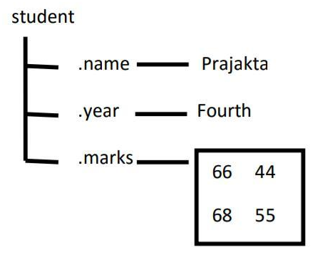
For example, consider a structured array of students which has different fields like name, year, and marks.

Each record in the array student has a structure of class Struct. The array of a structure is referred to as a struct as adding any new fields for a new struct in the array contains the empty array.

Creating Structured Array in Python NumPy
You can create a structured array in Python using the NumPy module. Follow the steps below to create a structured array:
Step 1: Import NumPy library
Step 2: Define the data type of structured array by creating a list of tuples, where each tuple contains the name of the field and its data type.
Step 3: You can now create the structured array using NumPy.array() method and set the dtype argument to the data type you defined in the previous step.

Example: Creating Structured Array in NumPy Python
import numpy as np
dt= np.dtype([('name', (np.str_, 10)), ('age', np.int32), ('weight', np.float64)])
a = np.array([('Sana', 2, 21.0), ('Mansi', 7, 29.0)],
dtype=dt)
print(a)
Output
[('Sana', 2, 21.0) ('Mansi', 7, 29.0)]

Structured Array Operations
Python offers many operations that you can perform on the structured array as a whole. These operations allow us to manipulate the entire structured array without worrying about individual fields.

Sorting Structured Array
The structure array can be sorted by using NumPy.sort() method and passing the order as the parameter. This parameter takes the value of the field according to which it is needed to be sorted.
Example:
import numpy as np
a = np.array([('Sana', 2, 21.0), ('Mansi', 7, 29.0)],
dtype=[('name', (np.str_, 10)), ('age', np.int32), ('weight', np.float64)])
# Sorting according to the name
b = np.sort(a, order='name')
print('Sorting according to the name', b)
# Sorting according to the age
b = np.sort(a, order='age')
print('\nSorting according to the age', b)
Output
Sorting according to the name [('Mansi', 7, 29.0) ('Sana', 2, 21.0)]
Sorting according to the age [('Sana', 2, 21.0) ('Mansi', 7, 29.0)]

Finding Min and Max in Structured Array
You can find the minimum and maximum of a structured array using the np.min() and np.max() functions and pass the fields in the function.
Example
import numpy as np
a = np.array([('Sana', 2, 21.0), ('Mansi', 7, 29.0)],
dtype=[('name', (np.str_, 10)), ('age', np.int32), ('weight', np.float64)])
max_age = np.max(a['age'])
min_age = np.min(a['age'])
print("Max age = ",max_age)
print("Min age = ", min_age)
Output
Max age = 7
Min age = 2

Concatenating Structured Array
You can use the np.concatenate() function to concatenate two structured arrays. Look at the example below showing the concatenation of two structured arrays.
Example
import numpy as np
a = np.array([('Sana', 2, 21.0), ('Mansi', 7, 29.0)],
dtype=[('name', (np.str_, 10)), ('age', np.int32), ('weight', np.float64)])
b = np.array([('Ayushi', 5, 30.0)], dtype=a.dtype)
c = np.concatenate((a, b))
print(c)
Output
[('Sana', 2, 21.) ('Mansi', 7, 29.) ('Ayushi', 5, 30.)]

Reshaping a Structured Array
You can reshape a structured array by using the NumPy.reshape() function.
Note: The total size of the structured array will remain the same.
Example
import numpy as np
a = np.array([('Sana', 2, 21.0), ('Mansi', 7, 29.0)],
dtype=[('name', (np.str_, 10)), ('age', np.int32), ('weight', np.float64)])
reshaped_a = np.reshape(a, (2, 1))
print(reshaped_a)
Output
[[('Sana', 2, 21.)]
[('Mansi', 7, 29.)]]

Why use Structured Array?
Structured arrays in NumPy allow us to work with arrays that contain elements of different data types. They are very useful in the case of tabular and structured data. Here are some uses of structured arrays:

Grouping Data
NumPy’s structured arrays allow us to group data of different data types and sizes. Each field in a structured array can contain data of any data type, making it a versatile tool for data grouping.

Tabular Data
Structured arrays can be a great tool when dealing with tabular data. They allow us to store and manipulate complex data structures with multiple fields, similar to a table or a spreadsheet.

Data Analysis
Structured arrays are very useful for data analysis. They provide efficient, flexible data containers that allow us to perform operations on entire datasets at once.

Memory efficiency
Structured arrays are memory-efficient. They allow us to store complex, heterogeneous data in a compact format, which can be important when working with large datasets.

Integrating with other libraries
Many Python libraries, such as Pandas and Scikit-learn, are built on top of NumPy and can work directly with structured arrays. This makes structured arrays a good choice when you need to integrate your code with other libraries.
Structured arrays are a very useful and convenient way of storing data. They allow us to store data with different data types, making them very useful for data science projects.

- INTRODUCTION TO PANDAS OBJECTS
Pandas, which is styled as pandas is an open-source software library designed for the Python programming language, focusing on data manipulation and analysis. It provides data structures like series and DataFrames to effectively easily clean, transform, and analyze large datasets and integrates seamlessly with other Python libraries, such as NumPy and Matplotlib.
It offers powerful functions for data transformation, aggregation, and visualization, which are important for credible analysis. Created by Wes McKinney in 2008, Pandas has grown to become a cornerstone of data analysis in Python, widely used by data scientists, analysts and researchers worldwide. Pandas revolves around two primary Data structures: Series (1D) for single columns and DataFrame (2D) for tabular data enabling efficient data manipulation.
Important Facts to Know :
- DataFrames: It is a two-dimensional data structure constructed with rows and columns, which is more similar to Excel spreadsheet.
- pandas: This name is derived for the term “panel data” which is econometrics terms of data sets.

What is Pandas Used for?
- With pandas, you can perform a wide range of data operations, including Reading and writing data from various file formats like CSV, Excel, and SQL databases.
- Cleaning and preparing data by handling missing values and filtering entries.
- Merging and joining multiple datasets seamlessly.
- Reshaping data through pivoting and stacking operations.
- Conducting statistical analysis and generating descriptive statistics.
- Visualizing data with integrated plotting capabilities.

Pandas Introduction
Pandas is a powerful and open-source Python library. The Pandas library is used for data manipulation and analysis. Pandas consist of data structures and functions to perform efficient operations on data.
Pandas is well-suited for working with tabular data, such as spreadsheets or SQL tables.

What is Python Pandas used for?
The Pandas library is generally used for data science, but have you wondered why? This is because the Pandas library is used in conjunction with other libraries that are used for data science. It is built on top of the NumPy library which means that a lot of the structures of NumPy are used or replicated in Pandas.
The data produced by Pandas is often used as input for plotting functions in Matplotlib, statistical analysis in SciPy, and machine learning algorithms in Scikit-learn.
Python’s Pandas library is the best tool to analyze, clean, and manipulate data.
Here is a list of things that we can do using Pandas.
- Data set cleaning, merging, and joining.
- Easy handling of missing data (represented as NaN) in floating point as well as non-floating point data.
- Columns can be inserted and deleted from DataFrame and higher-dimensional objects.
- Powerful group by functionality for performing split-apply-combine operations on data sets.
- Data Visualization.

Installing Pandas
The first step in working with Pandas is to ensure whether it is installed in the system or not. If not, then we need to install it on our system using the pip command.
For more reference, take a look at this article on installing pandas follows.

Importing Pandas
After the Pandas have been installed in the system, we need to import the library. This module is generally imported as follows:
import pandas as pd
Note: Here, pd is referred to as an alias for the Pandas. However, it is not necessary to import the library using the alias, it just helps in writing less code every time a method or property is called.

Data Structures in Pandas Library
Pandas generally provide two data structures for manipulating data. They are:
- Series
- DataFrame

Pandas Series
A Pandas Series is a one-dimensional labeled array capable of holding data of any type (integer, string, float, Python objects, etc.). The axis labels are collectively called indexes.

Creating a Series
Pandas Series is created by loading the datasets from existing storage (which can be a SQL database, a CSV file, or an Excel file).
Pandas Series can be created from lists, dictionaries, scalar values, etc.
Example: Creating a series using the Pandas Library.
import pandas as pd
import numpy as np
# Creating empty series
ser = pd.Series()
print("Pandas Series: ", ser)
# simple array
data = np.array(['g', 'e', 'e', 'k', 's'])
ser = pd.Series(data)
print("Pandas Series:\n", ser)
Output
Pandas Series: Series([], dtype: float64)
Pandas Series:
0 g
1 e
2 e
3 k
4 s
dtype: object

Pandas DataFrame
Pandas DataFrame is a two-dimensional data structure with labeled axes (rows and columns).

Creating DataFrame
Pandas DataFrame is created by loading the datasets from existing storage (which can be a SQL database, a CSV file, or an Excel file).
Pandas DataFrame can be created from lists, dictionaries, a list of dictionaries, etc.
Example: Creating a DataFrame Using the Pandas Library
import pandas as pd
# Calling DataFrame constructor
df = pd.DataFrame()
print(df)
# list of strings
lst = ['Geeks', 'For', 'Geeks', 'is', 'portal', 'for', 'Geeks']
# Calling DataFrame constructor on list
df = pd.DataFrame(lst)
print(df)
Output:
Empty DataFrame
Columns: []
Index: []
0 Geeks
1 For
2 Geeks
3 is
4 portal
5 for
6 Geeks

Pandas Dataframe Index
Index in pandas dataframe act as reference for each row in dataset. It can be numeric or based on specific column values. The default index is usually a RangeIndex starting from 0, but you can customize it for better data understanding. You can easily access the current index of a dataframe using the index attribute. Let's us understand with the help of an example:

1. Accessing and Modifying the Index
import pandas as pd
data = {'Name': ['John', 'Alice', 'Bob', 'Eve', 'Charlie'],
'Age': [25, 30, 22, 35, 28],
'Gender': ['Male', 'Female', 'Male', 'Female', 'Male'],
'Salary': [50000, 55000, 40000, 70000, 48000]}
df = pd.DataFrame(data)
print(df.index) # Accessing the index
Output
RangeIndex(start=0, stop=5, step=1)

2. Setting a Custom Index
To set a custom index, you can use the set_index() method, allowing you to set a custom index based on a column, such as Name or Age.
# Set 'Name' column as the index
df_with_index = df.set_index('Name')
print(df_with_index)
Output
Name Age Gender Salary
John 25 Male 50000
Alice 30 Female 55000
Bob 22 Male 40000
Eve 35 Female 70000
Charlie 28 Male 480...
There are various operations you can perform with the DataFrame index, such as resetting it, changing it, or indexing with loc[].

3. Resetting the Index
If you need to reset the index back to default integer index, use reset_index() method. This will convert the current index into a regular column and create a new default index.
# Reset the index back to the default integer index
df_reset = df.reset_index()
print(df_reset)
Output
Name Age Gender Salary
0 John 25 Male 50000
1 Alice 30 Female 55000
2 Bob 22 Male 40000
3 Eve 35 Female 70000
4 Charlie 28 Male 48000

4. Indexing with loc
The loc[] method in pandas allows to access rows and columns of a dataFrame using their labels, making it easy to retrieve specific data points.
row = df.loc['Alice']
print(row)
Output
Age 30
Gender Female
Salary 55000
Name: Alice, dtype: object

5. Changing the Index
Change the index of dataFrame, with help of set_index() method; allows to set one or more columns as the new index.
# Set 'Age' as the new index
df_with_new_index = df.set_index('Age')
print(df_with_new_index)
Output
Name Gender Salary
Age
25 John Male 50000
30 Alice Female 55000
22 Bob Male 40000
35 Eve Female 70000
28 Charlie Male 480...

Pandas Access DataFrame
Accessing a dataframe in pandas involves retrieving, exploring, and manipulating data stored within this structure. The most basic form of accessing a DataFrame is simply referring to it by its variable name. This will display the entire DataFrame, which includes all rows and columns.
import pandas as pd
data = {'Name': ['John', 'Alice', 'Bob', 'Eve', 'Charlie'],
'Age': [25, 30, 22, 35, 28],
'Gender': ['Male', 'Female', 'Male', 'Female', 'Male'],
'Salary': [50000, 55000, 40000, 70000, 48000]}
df = pd.DataFrame(data)
# Display the entire DataFrame
print(df)
Output
Name Age Gender Salary
0 John 25 Male 50000
1 Alice 30 Female 55000
2 Bob 22 Male 40000
3 Eve 35 Female 70000
4 Charlie 28 Male 48000
In addition to accessing the entire DataFrame there are several other methods to effectively retrieve and manipulate data within a Pandas DataFrame.

1. Accessing Columns From DataFrame
Columns in a DataFrame can be accessed individually using bracket notation Accessing a column retrieves that column as a Series, which can then be further manipulated.
# Access the 'Age' column
age_column = df['Age']
print(age_column)
Output
0 25
1 30
2 22
3 35
4 28
Name: Age, dtype: int64

2. Accessing Rows by Index
To access specific rows in a DataFrame, you can use iloc (for positional indexing) or loc (for label-based indexing). These methods allow you to retrieve rows based on their index positions or labels.
# Access the row at index 1 (second row)
second_row = df.iloc[1]
print(second_row)
Output
Name Alice
Age 30
Gender Female
Salary 55000
Name: 1, dtype: object

3. Accessing Multiple Rows or Columns
You can access multiple rows or columns at once by passing a list of column names or index positions. This is useful when you need to select several columns or rows for further analysis.
# Access the first three rows and the 'Name' and 'Age' columns
subset = df.loc[0:2, ['Name', 'Age']]
print(subset)
Output
Name Age
0 John 25
1 Alice 30
2 Bob 22

4. Accessing Rows Based on Conditions
Pandas allows you to filter rows based on conditions, which can be very powerful for exploring subsets of data that meet specific criteria.
# Access rows where 'Age' is greater than 25
filtered_data = df[df['Age'] > 25]
print(filtered_data)
Output
Name Age Gender Salary
1 Alice 30 Female 55000
3 Eve 35 Female 70000
4 Charlie 28 Male 48000

5. Accessing Specific Cells with at and iat
If you need to access a specific cell, you can use the .at[] method for label-based indexing and the .iat[] method for integer position-based indexing. These are optimized for fast access to single values.
# Access the 'Salary' of the row with label 2
salary_at_index_2 = df.at[2, 'Salary']
print(salary_at_index_2)
Output
40000
Here are some Key Takeaways:
- Access a DataFrame by its variable name to view all data, and use bracket notation for columns and loc/iloc for rows.
- Retrieve multiple rows or columns simultaneously by passing lists of names or indices.
- Filter rows based on conditions to explore specific subsets of data effectively.

- DATA INDEXING AND SELECTION

Indexing and Selecting Data with Pandas
Indexing in Pandas refers to selecting specific rows and columns from a DataFrame. It allows you to subset data in various ways, such as selecting all rows with specific columns, some rows with all columns, or a subset of both rows and columns. This technique is also known as Subset Selection.
Let’s learn how to use different techniques for indexing and selecting data with Pandas.

Indexing Data using the [] Operator
The most straightforward way to index data in Pandas is by using the [] operator. This method can be used to select individual columns or multiple columns.

Selecting a Single Column
To select a single column, you simply reference the column name inside square brackets:
import pandas as pd
# Load the data
data = pd.read_csv("nba.csv", index_col="Name")
print("Dataset")
display(data.head(5))
# Select a single column
first = data["Age"]
print("\nSingle Column selected from Dataset")
display(first.head(5))
Output:
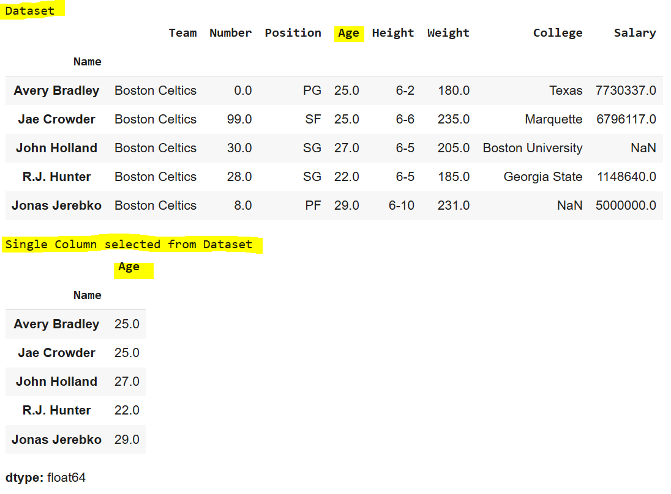

Selecting Multiple Columns
To select multiple columns, pass a list of column names:
first = data[["Age", "College", "Salary"]]
print("\nMultiple Columns selected from Dataset")
display(first.head(5))
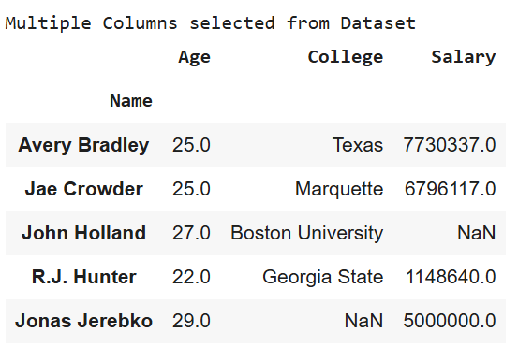
Output:

Pandas offers several indexing methods to efficiently extract elements, rows, and columns from a DataFrame. These methods, while similar, have distinct behaviors. The four main types of indexing in Pandas are:
- DataFrame[]: Known as the indexing operator, used for basic selection.
- DataFrame.loc[]: Label-based indexing for selecting data by row/column labels.
- DataFrame.iloc[]: Position-based indexing for selecting data by row/column integer positions.
Together, these indexing methods, also called “indexers,” are the most common ways to access data in a Pandas DataFrame.

Indexing a DataFrame using .loc[ ]
The .loc[] function in Pandas is used for selecting data by row and column labels. Unlike the indexing operator, .loc[] can select subsets of rows and columns simultaneously, offering flexibility in data retrieval.

Selecting a single row
To select a single row, provide the row label inside the .loc[] function:
# importing pandas package
import pandas as pd
# making data frame from csv file
data = pd.read_csv("nba.csv", index_col ="Name")
# retrieving row by loc method
first = data.loc["Avery Bradley"]
second = data.loc["R.J. Hunter"]
print(first, "\n\n\n", second)
Output:

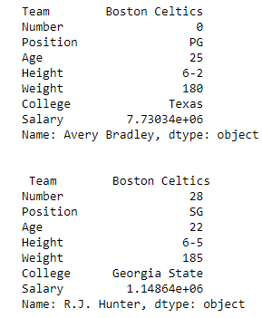

As shown in the output image, two series were returned since there was only one parameter both of the times.

Selecting multiple rows
For multiple rows, pass a list of row labels to .loc[]:
# Select multiple rows
first = data.loc[["Avery Bradley", "R.J. Hunter"]]
display(first)
Output:
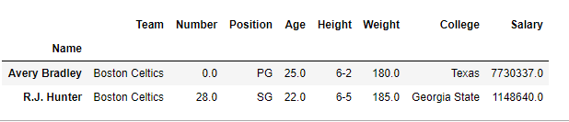

Selecting Specific Rows and Columns
To select specific rows and columns, provide both row labels and column names as lists:
Dataframe.loc[["row1", "row2"], ["column1", "column2", "column3"]]
# Select two rows and three columns
first = data.loc[["Avery Bradley", "R.J. Hunter"], ["Team", "Number", "Position"]]
print(first)
Output:


Selecting all of the rows and some columns
To select all rows and specific columns, use a colon [:] to indicate all rows, followed by the list of column names:
Dataframe.loc[:, ["column1", "column2", "column3"]]
# Select all rows and specific columns
first = data.loc[:, ["Team", "Number", "Position"]]
print(first)
Output:
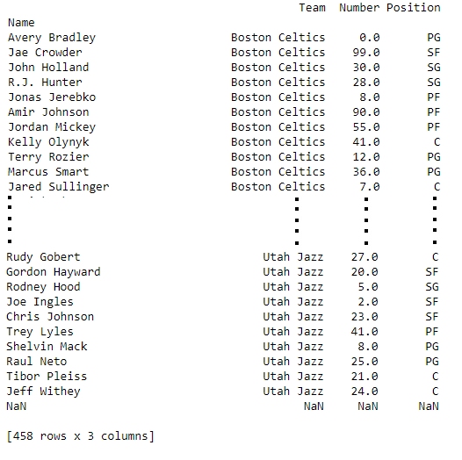
The .loc[] method in Pandas offers a powerful way to index and filter data using labels, making it a core tool for data selection.

Indexing a DataFrame using .iloc[ ]
The .iloc[] function in Pandas allows data selection based on integer positions (rather than labels). It is similar to .loc[], but only accepts integer-based indices to specify rows and columns.

Selecting a Single Row
To select a single row using .iloc[], provide the integer position of the row:
import pandas as pd
data = pd.read_csv("nba.csv", index_col="Name")
# Select a single row by position
row2 = data.iloc[3]
print(row2)
Output:
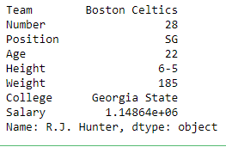

Selecting Multiple Rows
To select multiple rows, pass a list of integer positions:
# Select multiple rows by position
row2 = data.iloc[[3, 5, 7]]
display(row2)
Output:
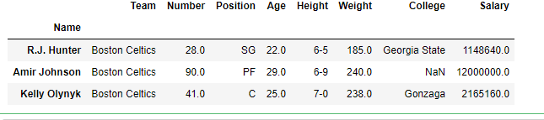

Selecting Specific Rows and Columns
To select specific rows and columns, provide integer positions for both rows and columns:
# Select two rows and two columns by position
row2 = data.iloc[[3, 4], [1, 2]]
print(row2)
Output:
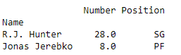

Selecting All Rows and Some Columns
To select all rows and specific columns, use a colon [:] for all rows and a list of column positions:
# Select all rows and specific columns
row2 = data.iloc[:, [1, 2]]
print(row2)
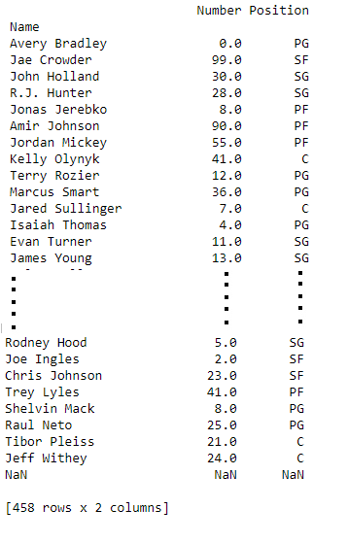
Output:

The .iloc[] method is a powerful way to select data by position, offering flexibility in accessing subsets of a DataFrame based on integer indexing.
Other methods for indexing in a Pandas DataFrame include:
deprecated ones:
Function | Description
DataFrame.head() | Return top n rows of a DataFrame.
DataFrame.tail() | Return bottom n rows of a DataFrame.
DataFrame.at[] | Access a single value for a row/column label pair.
DataFrame.iat[] | Access a single value for a row/column pair by integer position.
DataFrame.lookup() | Label-based “fancy indexing” function for DataFrame.
DataFrame.pop() | Return item and drop from DataFrame.
DataFrame.xs() | Return a cross-section (row(s) or column(s)) from the DataFrame.
DataFrame.get() | Get item from object for given key (e.g., DataFrame column).
DataFrame.isin() | Return a boolean DataFrame showing whether each element is contained in values.
DataFrame.where() | Return an object of the same shape with entries from self where cond is True, otherwise from other.
DataFrame.mask() | Return an object of the same shape with entries from self where cond is False, otherwise from other.
DataFrame.query() | Query the columns of a DataFrame with a boolean expression.
DataFrame.insert() | Insert a column into DataFrame at a specified location.
This table contains only active, non-deprecated methods for DataFrame indexing in Pandas. Let me know if you need more details!

Indexing and Selecting Data with Pandas – FAQs

What is indexing and selecting data with Pandas in Python?
Indexing and selecting data in Pandas refer to the methods used to access or modify specific rows and columns in a DataFrame or Series. This can be done using label indexing, integer indexing, or condition-based filtering.

How to select data based on index in Pandas?
You can select data by index using the loc and iloc attributes:
- loc: For label-based indexing (selects data by row labels and column names).
- iloc: For integer-based indexing (selects data by row and column positions).

What are the methods of indexing in pandas?
Pandas supports several methods of indexing:
  - Label-based indexing (loc): Selects data based on data index value labels.
  - Integer-based indexing (iloc): Selects data based on the integer position of rows and columns.
  - Boolean indexing: Uses a boolean vector to filter data.
  - Conditional indexing: Uses conditions to filter rows or columns.
  - MultiIndex (hierarchical): Advanced indexing on multiple levels of index rows or columns.

What are types of indexing?
In the broader context beyond pandas, types of indexing include:
  - Single-level indexing: Regular index with a single label for each entry.
  - Multi-level indexing (Hierarchical): Multiple index levels, allowing for more complex data arrangements.
  - Datetime indexing: Specific to time series data, allowing date and time-based indexing.
  - Interval indexing: For data indexed by ranges of values.
  - Categorical indexing: For data categorized based on specific criteria.

What is indexing method?
An indexing method defines how data is organized and accessed within a structure like a DataFrame or Series. It determines the efficiency of data retrieval and manipulation.

- OPERATING ON DATA IN PANDAS
https://jakevdp.github.io/PythonDataScienceHandbook/03.03-operations-in-pandas.html
One of the essential pieces of NumPy is the ability to perform quick element-wise operations, both with basic arithmetic (addition, subtraction, multiplication, etc.) and with more sophisticated operations (trigonometric functions, exponential and logarithmic functions, etc.). Pandas inherits much of this functionality from NumPy, and the ufuncs that we introduced in Computation on NumPy Arrays: Universal Functions are key to this.
Pandas includes a couple useful twists, however: for unary operations like negation and trigonometric functions, these ufuncs will preserve index and column labels in the output, and for binary operations such as addition and multiplication, Pandas will automatically align indices when passing the objects to the ufunc. This means that keeping the context of data and combining data from different sources–both potentially error-prone tasks with raw NumPy arrays–become essentially foolproof ones with Pandas. We will additionally see that there are well-defined operations between one-dimensional Series structures and two-dimensional DataFrame structures.

Ufuncs: Index Preservation
Because Pandas is designed to work with NumPy, any NumPy ufunc will work on Pandas Series and DataFrame objects. Let's start by defining a simple Series and DataFrame on which to demonstrate this:
In [1]:
import pandas as pd
import numpy as np
In [2]:
rng = np.random.RandomState(42)
ser = pd.Series(rng.randint(0, 10, 4))
ser
Out[2]:
0 6
1 3
2 7
3 4
dtype: int64
In [3]:
df = pd.DataFrame(rng.randint(0, 10, (3, 4)),
columns=['A', 'B', 'C', 'D'])
df
Out[3]:
 | A | B | C | D
0 | 6 | 9 | 2 | 6
1 | 7 | 4 | 3 | 7
2 | 7 | 2 | 5 | 4
If we apply a NumPy ufunc on either of these objects, the result will be another Pandas object with the indices preserved:
In [4]:
np.exp(ser)
Out[4]:
0 403.428793
1 20.085537
2 1096.633158
3 54.598150
dtype: float64
Or, for a slightly more complex calculation:
In [5]:
np.sin(df * np.pi / 4)
Out[5]:
 | A | B | C | D
0 | -1.000000 | 7.071068e-01 | 1.000000 | -1.000000e+00
1 | -0.707107 | 1.224647e-16 | 0.707107 | -7.071068e-01
2 | -0.707107 | 1.000000e+00 | -0.707107 | 1.224647e-16
Any of the ufuncs discussed in Computation on NumPy Arrays: Universal Functions can be used in a similar manner.

UFuncs: Index Alignment
For binary operations on two Series or DataFrame objects, Pandas will align indices in the process of performing the operation. This is very convenient when working with incomplete data, as we'll see in some of the examples that follow.

Index alignment in Series
As an example, suppose we are combining two different data sources, and find only the top three US states by area and the top three US states by population:
In [6]:
area = pd.Series({'Alaska': 1723337, 'Texas': 695662,
'California': 423967}, name='area')
population = pd.Series({'California': 38332521, 'Texas': 26448193,
'New York': 19651127}, name='population')
Let's see what happens when we divide these to compute the population density:
In [7]:
population / area
Out[7]:
Alaska NaN
California 90.413926
New York NaN
Texas 38.018740
dtype: float64
The resulting array contains the union of indices of the two input arrays, which could be determined using standard Python set arithmetic on these indices:
In [8]:
area.index | population.index
Out[8]:
Index(['Alaska', 'California', 'New York', 'Texas'], dtype='object')
Any item for which one or the other does not have an entry is marked with NaN, or "Not a Number," which is how Pandas marks missing data (see further discussion of missing data in Handling Missing Data). This index matching is implemented this way for any of Python's built-in arithmetic expressions; any missing values are filled in with NaN by default:
In [9]:
A = pd.Series([2, 4, 6], index=[0, 1, 2])
B = pd.Series([1, 3, 5], index=[1, 2, 3])
A + B
Out[9]:
0 NaN
1 5.0
2 9.0
3 NaN
dtype: float64
If using NaN values is not the desired behavior, the fill value can be modified using appropriate object methods in place of the operators. For example, calling A.add(B) is equivalent to calling A + B, but allows optional explicit specification of the fill value for any elements in A or B that might be missing:
In [10]:
A.add(B, fill_value=0)
Out[10]:
0 2.0
1 5.0
2 9.0
3 5.0
dtype: float64

Index alignment in DataFrame
A similar type of alignment takes place for both columns and indices when performing operations on DataFrames:
In [11]:
A = pd.DataFrame(rng.randint(0, 20, (2, 2)),
columns=list('AB'))
A
Out[11]:
 | A | B
0 | 1 | 11
1 | 5 | 1
In [12]:
B = pd.DataFrame(rng.randint(0, 10, (3, 3)),
columns=list('BAC'))
B
Out[12]:
 | B | A | C
0 | 4 | 0 | 9
1 | 5 | 8 | 0
2 | 9 | 2 | 6
In [13]:
A + B
Out[13]:
 | A | B | C
0 | 1.0 | 15.0 | NaN
1 | 13.0 | 6.0 | NaN
2 | NaN | NaN | NaN
Notice that indices are aligned correctly irrespective of their order in the two objects, and indices in the result are sorted. As was the case with Series, we can use the associated object's arithmetic method and pass any desired fill_value to be used in place of missing entries. Here we'll fill with the mean of all values in A (computed by first stacking the rows of A):
In [14]:
fill = A.stack().mean()
A.add(B, fill_value=fill)
Out[14]:
 | A | B | C
0 | 1.0 | 15.0 | 13.5
1 | 13.0 | 6.0 | 4.5
2 | 6.5 | 13.5 | 10.5
The following table lists Python operators and their equivalent Pandas object methods:
Python Operator | Pandas Method(s)
+ | add()
- | sub(), subtract()
* | mul(), multiply()
/ | truediv(), div(), divide()
// | floordiv()
% | mod()
** | pow()

Ufuncs: Operations Between DataFrame and Series
When performing operations between a DataFrame and a Series, the index and column alignment is similarly maintained. Operations between a DataFrame and a Series are similar to operations between a two-dimensional and one-dimensional NumPy array. Consider one common operation, where we find the difference of a two-dimensional array and one of its rows:
In [15]:
A = rng.randint(10, size=(3, 4))
A
Out[15]:
array([[3, 8, 2, 4],
[2, 6, 4, 8],
[6, 1, 3, 8]])
In [16]:
A - A[0]
Out[16]:
array([[ 0, 0, 0, 0],
[-1, -2, 2, 4],
[ 3, -7, 1, 4]])
According to NumPy's broadcasting rules (see Computation on Arrays: Broadcasting), subtraction between a two-dimensional array and one of its rows is applied row-wise.
In Pandas, the convention similarly operates row-wise by default:
In [17]:
df = pd.DataFrame(A, columns=list('QRST'))
df - df.iloc[0]
Out[17]:
 | Q | R | S | T
0 | 0 | 0 | 0 | 0
1 | -1 | -2 | 2 | 4
2 | 3 | -7 | 1 | 4
If you would instead like to operate column-wise, you can use the object methods mentioned earlier, while specifying the axis keyword:
In [18]:
df.subtract(df['R'], axis=0)
Out[18]:
 | Q | R | S | T
0 | -5 | 0 | -6 | -4
1 | -4 | 0 | -2 | 2
2 | 5 | 0 | 2 | 7
Note that these DataFrame/Series operations, like the operations discussed above, will automatically align indices between the two elements:
In [19]:
halfrow = df.iloc[0, ::2]
halfrow
Out[19]:
Q 3
S 2
Name: 0, dtype: int64
In [20]:
df - halfrow
Out[20]:
 | Q | R | S | T
0 | 0.0 | NaN | 0.0 | NaN
1 | -1.0 | NaN | 2.0 | NaN
2 | 3.0 | NaN | 1.0 | NaN
This preservation and alignment of indices and columns means that operations on data in Pandas will always maintain the data context, which prevents the types of silly errors that might come up when working with heterogeneous and/or misaligned data in raw NumPy arrays.

- HANDLING MISSING DATA

Working with Missing Data in Pandas
In Pandas, missing values are represented by None or NaN, which can occur due to uncollected data or incomplete entries. Let’s explore how to detect, handle, and fill in missing values in a DataFrame to ensure accurate analysis.
Table of Content
  - Checking for Missing Values in Pandas DataFrame
  - Filling Missing Values in Pandas
  - Dropping Missing Values in Pandas

Checking for Missing Values in Pandas DataFrame
To identify and handle the missing values, Pandas provides two useful functions: isnull() and notnull(). These functions help detect whether a value is NaN or not, making it easier to clean and preprocess data in a DataFrame or Series.

1. Checking for Missing Values Using isnull()
isnull() returns a DataFrame of Boolean values, where True represents missing data (NaN). This is useful when you want to locate and address missing data within a dataset.
Example 1: Detecting Missing Values in a DataFrame
# Importing pandas and numpy
import pandas as pd
import numpy as np
# Sample DataFrame with missing values
data = {'First Score': [100, 90, np.nan, 95],
'Second Score': [30, 45, 56, np.nan],
'Third Score': [np.nan, 40, 80, 98]}
df = pd.DataFrame(data)
# Checking for missing values using isnull()
missing_values = df.isnull()
print(missing_values)
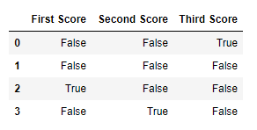
Output:

Example 2: Filtering Data Based on Missing Values
In this case, the isnull() function is applied to the “Gender” column to filter and display rows with missing gender information.
import pandas as pd
data = pd.read_csv("employees.csv")
bool_series = pd.isnull(data["Gender"])
missing_gender_data = data[bool_series]
print(missing_gender_data)
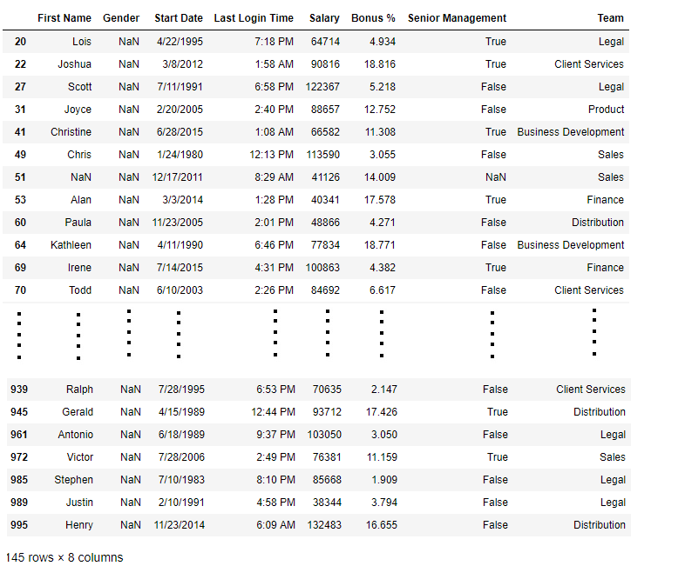
Output:

Checking for Missing Values Using notnull()
notnull() returns a DataFrame of Boolean values, where True indicates non-missing data. This function can be useful when you want to focus on the rows that contain valid, non-missing data.
Example 3: Detecting Non-Missing Values in a DataFrame
# Importing pandas and numpy
import pandas as pd
import numpy as np
# Sample DataFrame with missing values
data = {'First Score': [100, 90, np.nan, 95],
'Second Score': [30, 45, 56, np.nan],
'Third Score': [np.nan, 40, 80, 98]}
df = pd.DataFrame(data)
# Checking for non-missing values using notnull()
non_missing_values = df.notnull()
print(non_missing_values)
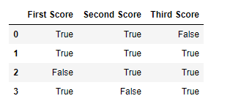
Output:

Example 4: Filtering Data with Non-Missing Values
This code snippet uses the notnull() function to filter out rows where the “Gender” column does not have missing values.
# Importing pandas
import pandas as pd
# Reading data from a CSV file
data = pd.read_csv("employees.csv")
# Identifying non-missing values in the 'Gender' column
non_missing_gender = pd.notnull(data["Gender"])
# Filtering rows where 'Gender' is not missing
non_missing_gender_data = data[non_missing_gender]
display(non_missing_gender_data)
Output:
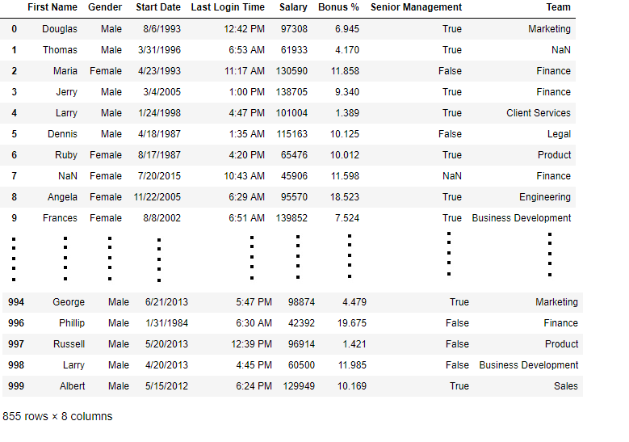

Filling Missing Values in Pandas Using fillna(), replace(), and interpolate()
When working with missing data in Pandas, the fillna(), replace(), and interpolate() functions are commonly used to fill NaN values. These functions allow you to replace missing values with a specific value or use interpolation techniques.

1. Filling Missing Values with a Specific Value Using fillna()
The fillna() function is used to replace missing values (NaN) with a specified value. For example, you can fill missing values with 0.
Example: Fill Missing Values with Zero
import pandas as pd
import numpy as np
dict = {'First Score': [100, 90, np.nan, 95],
'Second Score': [30, 45, 56, np.nan],
'Third Score': [np.nan, 40, 80, 98]}
df = pd.DataFrame(dict)
# Filling missing values with 0
df.fillna(0)
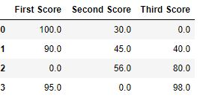
Output:

2. Filling Missing Values with the Prev/Next Value Using fillna
You can use the pad method to fill missing values with the previous value, or bfill to fill with the next value. We will be using the above dataset for the demonstration.
Example: Fill with Previous Value (Forward Fill)
df.fillna(method='pad') # Forward fill
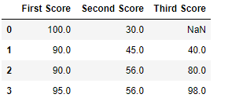
Output:

Example: Fill with Next Value (Backward Fill)
df.fillna(method='bfill') # Backward fill
Output:
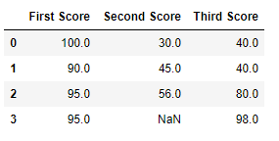

Example: Fill NaN Values with ‘No Gender’ using fillna()
import pandas as pd
import numpy as np
data = pd.read_csv("employees.csv")
# Print records from 10th row to 24th row
data[10:25]
Output
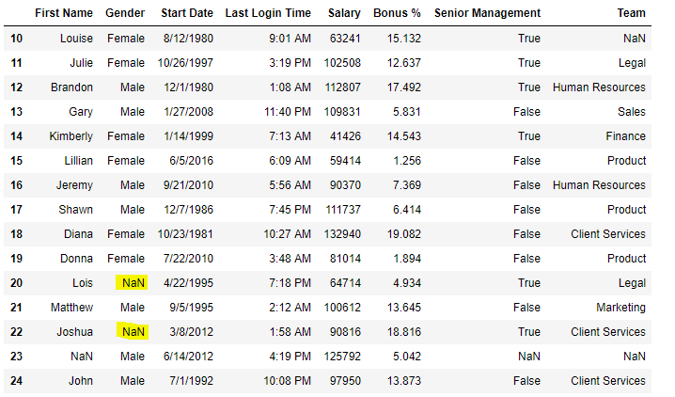
Now we are going to fill all the null values in Gender column with “No Gender”
# filling a null values using fillna()
data["Gender"].fillna('No Gender', inplace = True)
data[10:25]
Output:
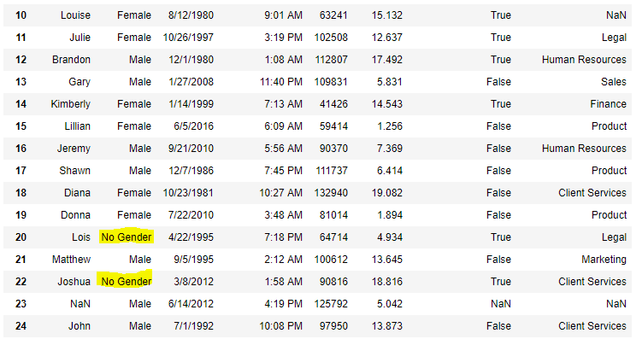
3. Replacing Missing Values Using replace()
Use replace() to replace NaN values with a specific value like -99.
Example: Replace NaN with -99
import pandas as pd
import numpy as np
data = pd.read_csv("employees.csv")
data[10:25]
Output:
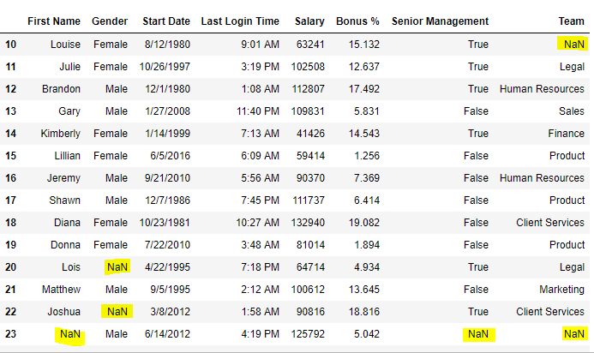

Now, we are going to replace the all Nan value in the data frame with -99 value.
data.replace(to_replace=np.nan, value=-99)
Output:
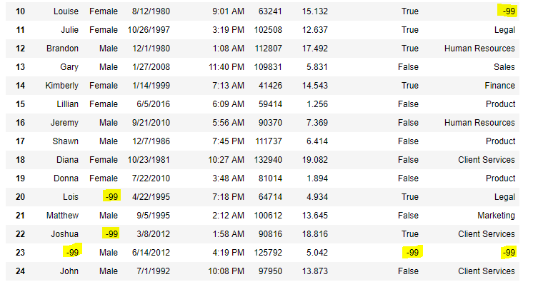

4. Filling Missing Values Using interpolate()
The interpolate() function fills missing values using interpolation techniques, such as the linear method.
Example: Linear Interpolation
# importing pandas as pd
import pandas as pd
# Creating the dataframe
df = pd.DataFrame({"A": [12, 4, 5, None, 1],
"B": [None, 2, 54, 3, None],
"C": [20, 16, None, 3, 8],
"D": [14, 3, None, None, 6]})
# Print the dataframe
print(df)

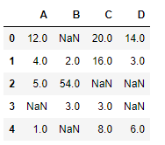
Output:

Let’s interpolate the missing values using Linear method. Note that Linear method ignore the index and treat the values as equally spaced.
# to interpolate the missing values
df.interpolate(method ='linear', limit_direction ='forward')
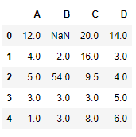
Output:

This method fills missing values by treating the data as equally spaced.

Dropping Missing Values in Pandas Using dropna()
The dropna()function in Pandas removes rows or columns with NaN values. It can be used to drop data based on different conditions.

1. Dropping Rows with At Least One Null Value
Use dropna() to remove rows that contain at least one missing value.
Example: Drop Rows with At Least One NaN
import pandas as pd
import numpy as np

dict = {'First Score': [100, 90, np.nan, 95],
'Second Score': [30, np.nan, 45, 56],
'Third Score': [52, 40, 80, 98],
'Fourth Score': [np.nan, np.nan, np.nan, 65]}
df = pd.DataFrame(dict)
# Drop rows with at least one missing value
df.dropna()
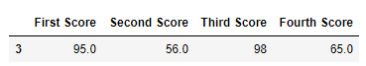
Output:

2. Dropping Rows with All Null Values
You can drop rows where all values are missing using dropna(how=’all’).
Example: Drop Rows with All NaN Values
dict = {'First Score': [100, np.nan, np.nan, 95],
'Second Score': [30, np.nan, 45, 56],
'Third Score': [52, np.nan, 80, 98],
'Fourth Score': [np.nan, np.nan, np.nan, 65]}
df = pd.DataFrame(dict)
# Drop rows where all values are missing
df.dropna(how='all')
Output:
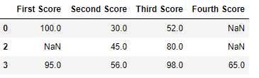

3. Dropping Columns with At Least One Null Value
To remove columns that contain at least one missing value, use dropna(axis=1).
Example: Drop Columns with At Least One NaN
dict = {'First Score': [100, np.nan, np.nan, 95],
'Second Score': [30, np.nan, 45, 56],
'Third Score': [52, np.nan, 80, 98],
'Fourth Score': [np.nan, 67, 68, 65]}
df = pd.DataFrame(dict)
# Drop columns with at least one missing value
df.dropna(axis=1)
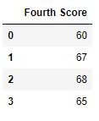
Output :

4. Dropping Rows with Missing Values in CSV Files
When working with data from CSV files, you can drop rows with missing values using dropna().
Example: Drop Rows with NaN in a CSV File
import pandas as pd
data = pd.read_csv("employees.csv")
# Drop rows with any missing value
new_data = data.dropna(axis=0, how='any')
# Compare lengths of original and new dataframes
print("Old data frame length:", len(data))
print("New data frame length:", len(new_data))
print("Rows with at least one missing value:", (len(data) - len(new_data)))
Output :
Old data frame length: 1000
New data frame length: 764
Rows with at least one missing value: 236
Since the difference is 236, there were 236 rows which had at least 1 Null value in any column.

Working with Missing Data in Pandas – FAQs

How to get rows with missing data in pandas?
Use isna() combined with any() to find rows with missing values:
import pandas as pd
df = pd.DataFrame({
‘A’: [1, 2, None, 4],
‘B’: [‘a’, ‘b’, ‘c’, None]
})
rows_with_missing = df[df.isna().any(axis=1)]
print(rows_with_missing)

How to handle missing data in a dataset?
  - Remove missing data: Use dropna() to remove rows or columns with missing values.
  - Fill missing data: Use fillna() to fill missing values with a specific value or a calculated statistic like mean or median.
  - Interpolation: For numerical data, use interpolate() to estimate missing values.

How to fill missing values in pandas using mean?
Fill missing numerical values with the column mean using fillna():
df[‘A’] = df[‘A’].fillna(df[‘A’].mean())

What are some methods to handle missing or corrupted data?
  - Imputation: Replace missing values with mean, median, or mode.
  - Algorithms supporting missing data: Some ML algorithms handle missing values directly.
  - Prediction: Use models to predict missing values based on other data.

How to count missing values in pandas?
Count missing values per column with isna() and sum():
missing_value_count = df.isna().sum()

- HIERARCHICAL INDEXING
The index is like an address, that’s how any data point across the data frame or series can be accessed. Rows and columns both have indexes, rows indices are called index and for columns, it’s general column names.

Hierarchical Indexes
Hierarchical Indexes are also known as multi-indexing is setting more than one column name as the index. In this article, we are going to use homelessness.csv file.
# importing pandas library as alias pd
import pandas as pd
# calling the pandas read_csv() function.
# and storing the result in DataFrame df
df = pd.read_csv('homelessness.csv')
print(df.head())
Output:

In the following data frame, there is no indexing.
Columns in the Dataframe:
# using the pandas columns attribute.
col = df.columns
print(col)
Output:
Index([‘Unnamed: 0’, ‘region’, ‘state’, ‘individuals’, ‘family_members’,
‘state_pop’],
dtype=’object’)
To make the column an index, we use the Set_index() function of pandas. If we want to make one column an index, we can simply pass the name of the column as a string in set_index(). If we want to do multi-indexing or Hierarchical Indexing, we pass the list of column names in the set_index().
Below Code demonstrates Hierarchical Indexing in pandas:
# using the pandas set_index() function.
df_ind3 = df.set_index(['region', 'state', 'individuals'])
# we can sort the data by using sort_index()
df_ind3.sort_index()
print(df_ind3.head(10))
Output:
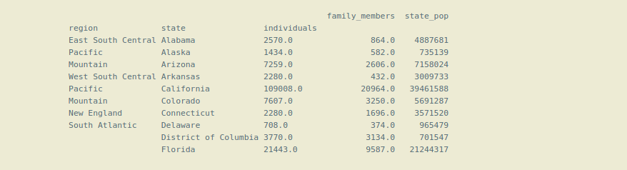
Now the dataframe is using Hierarchical Indexing or multi-indexing.
Note that here we have made 3 columns as an index (‘region’, ‘state’, ‘individuals’ ). The first index ‘region’ is called level(0) index, which is on top of the Hierarchy of indexes, next index ‘state’ is level(1) index which is below the main or level(0) index, and so on. So, the Hierarchy of indexes is formed that’s why this is called Hierarchical indexing.
We may sometimes need to make a column as an index, or we want to convert an index column into the normal column, so there is a pandas reset_index(inplace = True) function, which makes the index column the normal column.
Selecting Data in a Hierarchical Index or using the Hierarchical Indexing:
For selecting the data from the dataframe using the .loc() method we have to pass the name of the indexes in a list.
# selecting the 'Pacific' and 'Mountain'
# region from the dataframe.

# selecting data using level(0) index or main index.
df_ind3_region = df_ind3.loc[['Pacific', 'Mountain']]
print(df_ind3_region.head(10))

Output:

We cannot use only level(1) index for getting data from the dataframe, if we do so it will give an error. We can only use level (1) index or the inner indexes with the level(0) or main index with the help list of tuples.
# using the inner index 'state' for getting data.
df_ind3_state = df_ind3.loc[['Alaska', 'California', 'Idaho']]

print(df_ind3_state.head(10))
Output:
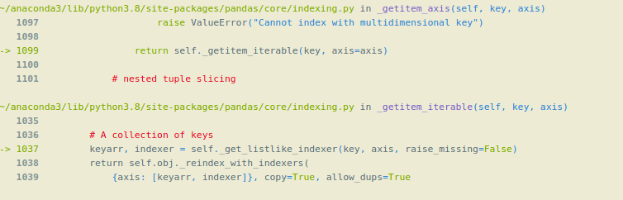
Using inner levels indexes with the help of a list of tuples:
Syntax:
df.loc[[ ( level( 0 ) , level( 1 ) , level( 2 ) ) ]]
# selecting data by passing all levels index.
df_ind3_region_state = df_ind3.loc[[("Pacific", "Alaska", 1434),
("Pacific", "Hawaii", 4131),
("Mountain", "Arizona", 7259),
("Mountain", "Idaho", 1297)]]
df_ind3_region_state
Output:


